**EMO Hannover 2019: Smart Data Analysis Is the MUST for Standardized Mold Making**

As EMO motto says “Smart technologies driving tomorrow’s production”, Beijing Jingdiao Group, a Chinese machine tool company, also believe in this and has been working on intelligent manufacturing since its foundation in 1994.

Based on its complete product system and technology, Jingdiao becomes the one to call for ingenious and time proven solutions for those difficult applications that everyone else stays clear of.

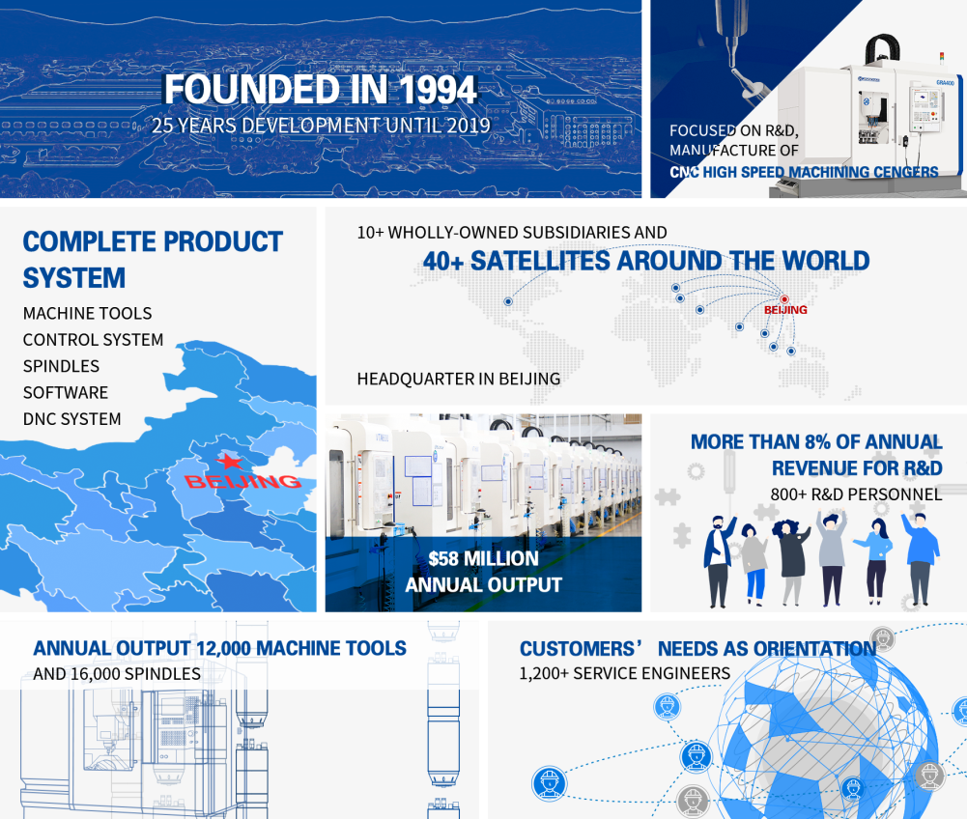

During EMO 2019, they’ll exhibit how to realize standardized mold making without secondary operation using their on-machine measurement and intelligent modification technology.

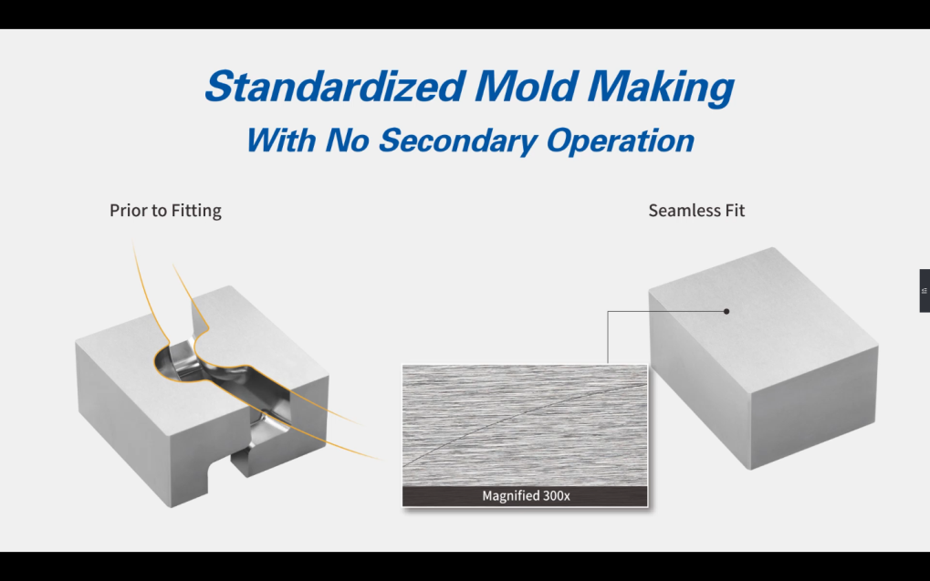

The secret is measuring the remaining stock of mold surface after specific processes, such as semi-finishing. Due to the seamless integration between Jingdiao CADCAM software, control system and high-speed machine tool, the collected data will be displayed on the screen of control system in real time, which makes it possible for technicians to see if the mold is qualified and adjust the process quickly if something goes wrong. Thus, the remaining stock of the finished mold will be precisely controlled and can fit each other seamlessly and mutually.

